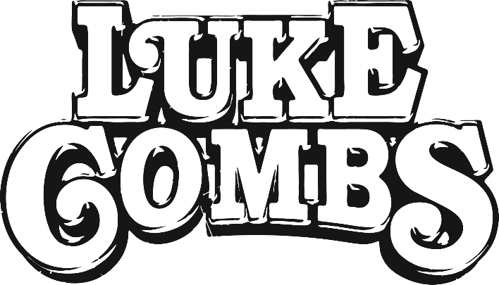

“one of music’s mightiest voices and a hitmaking force arguably unlike any seen out Nashville this century”—USA Today
“a superstar who is shaping the future of the genre while also serving as one of its fiercest defenders” —The Washington Post
CURRENT SINGLE: “Going, Going, Gone”
ALBUM: Gettin’ Old (out March 24) + Growin’ Up (out now)
LABEL: River House Artists / Columbia Nashville
- New album Gettin' Old to be released March 24—a companion to 2022’s acclaimed record, Growin' Up
- Gettin’ Old features 18 new songs including the already released “Growin’ Up and Gettin’ Old” and “Love You Anyway,” as well as a new rendition of Tracy Chapman’s “Fast Car”
- Record-breaking World Tour starts next month with 39 shows across 3 continents and 16 countries, with 16 sold-out stadium dates in North America—the largest world tour ever for a country artist
- Combs’ current single, “Going, Going, Gone,” is currently top 3 at country radio and rising
- Recently achieved record-breaking 14th-consecutive #1 single with “The Kind of Love We Make,” which also reached #8 on the all-genre Billboard Hot 100 chart
- Won Entertainer of the Year and Album of the Year at the 2022 CMA Awards – the first artist to receive both awards in the same night since 2013 and his second-consecutive year winning Entertainer of the Year
- GRAMMY-nominated album Growin’ Up debuted at #1 on Billboard’s Top Country Albums chart this past June
- Over 15 million monthly Spotify listeners
- Broke the record for most #1 singles to come from the same album with seven #1s from What You See Ain’t Always What You Get.
- 4x Platinum-certified single, “Forever After All,” debuted at #2 on the Billboard Hot 100—the highest entrance ever for a male country solo artist.
- Combs reached #1 on Rolling Stone’s Top 200 Albums chart, Top 100 Songs chart and Artists 500 chart with the deluxe album—the first country artist ever to lead all three charts in the same week and first to top the Artists 500.
- 8x CMA Award winner—Entertainer of the Year (2022, 2021), Album of the Year (2022, 2020), Male Vocalist of the Year (2020, 2019), Song of the Year (2019) and New Artist of the Year (2018)
- 6x GRAMMY nominee—Best Country Album (2023), Best Country Song (2023), Best Country Duo/Group Performance (2023, 2020), Best Country Solo Performance (2022) and Best New Artist (2019)
- Named Songwriter-Artist of the Year at 2021 Nashville Songwriter Awards
- 3x ACM Award winner—Male Artist of the Year (2020), Album of the Year (2020, What You See Is What You Get) and New Male Artist of the Year (2019)
- 3x Billboard Music Award winner—2019 Top Country Artist, Top Country Male Artist and Top Country Album.
- 3x iHeartRadio Music Award winner—Country Artist of the Year (2021), Album of the Year (2020, What You See Ain’t Always What You Get) and Country Artist of the Year (2019)
- Selected as a 2022 CMT “Artists of the Year” honoree.
- First artist ever to have their first two studio albums spend 25 weeks or more at #1 on Billboard’s Top Country Albums chart—breaking Taylor Swift’s previously held record at 24 weeks.
- First artist in history to simultaneously top all five Billboard country charts for multiple weeks: Top Country Albums, Hot Country Songs, Country Airplay, Country Streaming Songs and Country Digital Songs.
- Inducted as a member of the Grand Ole Opry.

LukeCombs.com | Facebook.com/LukeCombsMusic | Instagram.com/LukeCombsMusic | Twitter.com/LukeCombsMusic

