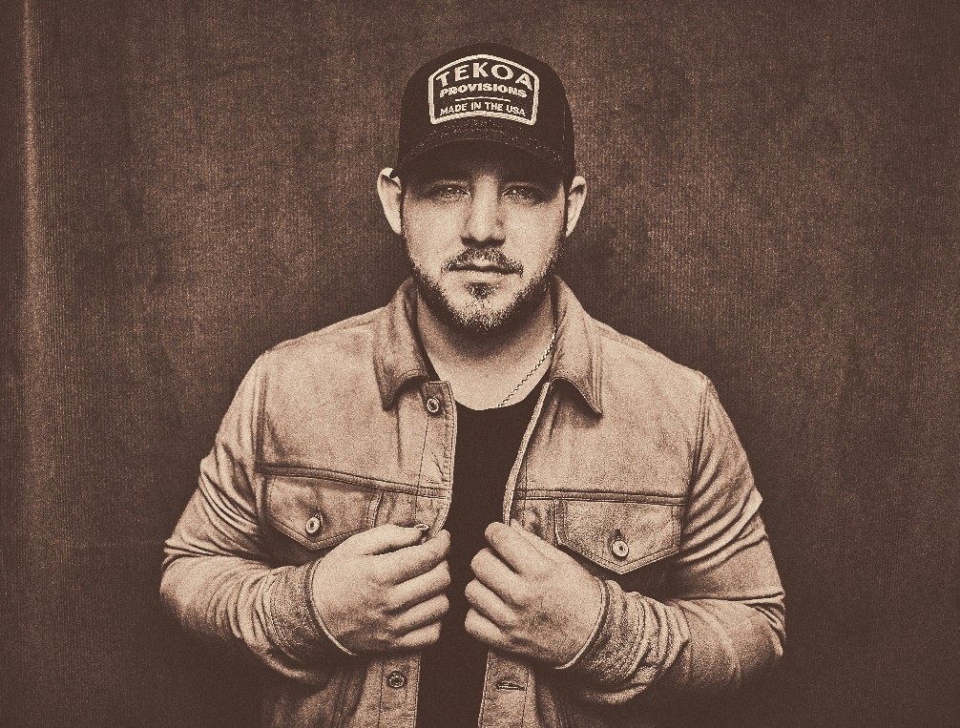
Hi-res image here
“Kameron Marlowe is another dark horse in the Nashville scene and he is bound to have a spark ignite to the top of the charts sooner than later.” – BroBible
“Kameron Marlowe in many ways feels like the piece country music has been missing.” - EverythingNash
“Kameron Marlowe is on the fast track to stardom.” – MusicRow
“You couldn’t ask for a better debut into the country scene and I believe Kameron Marlowe is here for the long run.” – Raised On It

- 25-year-old Kannapolis, NC native Kameron Marlowe has blasted onto the scene with his gritty country sound and growling vocals, earning more than 559 million on-demand career streams.

- Debut album We Were Cowboys is available now via Columbia Nashville/Sony Music Nashville.

- Produced by ACM/CMA winner Dann Huff and GRAMMY nominee Brad Hill (“Giving You Up,” “Burn ‘Em All”), We Were Cowboys features a massive 16-song track list and a bold, take-me-as-I-come spirit. Marlowe had a hand in writing 10 of those tracks.

- His headlining WE WERE COWBOYS TOUR ran through fall 2022, kicking off with a sold-out show at Nashville’s Brooklyn Bowl. Marlowe sold more than 22,000 tickets and played to capacity crowds in New York City, Washington, D.C., Boston, Birmingham, Chesapeake, VA, Charlotte (his hometown), and more.
- Has earned RIAA Gold certification for “Burn ‘Em All” and Platinum certification for his debut release “Giving You Up.”
- Has opened for Morgan Wallen, Luke Combs, Thomas Rhett, Brad Paisley, Riley Green, Lee Brice, and more. Joining Dierks Bentley, Chase Rice, and Parker McCollum on select dates throughout summer 2023.
- Named to CMT’s Listen Up and Opry NextStage new artist programs for 2023.

- Tapped an Artist to Watch by more than a dozen media outlets and partners including Amazon Music, Spotify, Pandora, Sounds Like Nashville, Country Now, Country Insider, NY Country Swag, Music Mayhem, Entertainment Focus, Everything Nash, Country Music Tattle Tale, and more.

- Influenced by artists ranging from Brooks & Dunn and George Strait to Travis Tritt and Ray Charles, Marlowe’s sound is a culmination of his life-long love of country music. His first memories include riding around in his grandpa’s truck listening to Garth Brooks and Darius Rucker.
KameronMarlowe.com | Facebook | Twitter | Instagram | YouTube | TikTok

