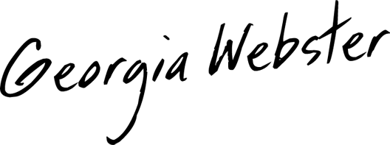
“Enchanting. Her sweet/tart soprano has folk overtones and hidden strength.” – Music Row
“Ever since we discovered her existence and the magical way she writes and sings, we’ve been obsessed and can’t stop listening!” – The Honey Pop
“[Georgia’s] shimmering vocals melt the line between pop and country…” – Earmilk
“Georgia’s relatable lyrics and dreamy vocals make this one of our favorites for summer!” – Guitar Girl Magazine

- Georgia Webster released her introductory EP First Goodbye on July 16, listen HERE. She solo wrote every song on the project, which was deemed “a treasure of an album” by People Magazine.

- The singer-songwriter signed to River House Artists/Sony Music Nashville in March 2021, releasing her major label debut “Push and Pull” at the same time. “Push and Pull” follows Webster’s debut track, streaming hit and TikTok sensation “Tell Your Mom,” which arrived in October 2020.

- Georgia is currently on the road with Ingrid Andress, opening for her Feeling Things Tour 2021.

- Georgia recently debuted music videos for her songs “First Goodbye,” “Box of Memories,” and “Tell Your Mom.”

- A native of tiny Hampden, MA, Webster grew up listening to a variety of music, from John Mayer and Miley Cyrus to Carrie Underwood, Keane, and the Grateful Dead. She started performing around her hometown while in high school, playing original songs that reflected her pop influence and love for country music.

- Webster then honed her craft by attending the prestigious Berklee College of Music’s songwriter camps, and her natural talent blossomed.
- In July 2020, her song “Tell Your Mom” became an instant viral hit on TikTok, amassing more than two million views in just a few days. Georgia’s success on TikTok brought impressive offers from pop and rock record labels out of New York and Los Angeles.
- Georgia teamed up with songwriter/producer Paul DiGiovanni (Sam Hunt, Lauren Alaina, Jordan Davis, Dan + Shay) to create the studio version of “Tell Your Mom,” which retains the acoustic spark of the original TikTok performance.

ItsGeorgiaWebster.com | Facebook | TikTok | Instagram | YouTube

