TALK POINTS // 2.13.24

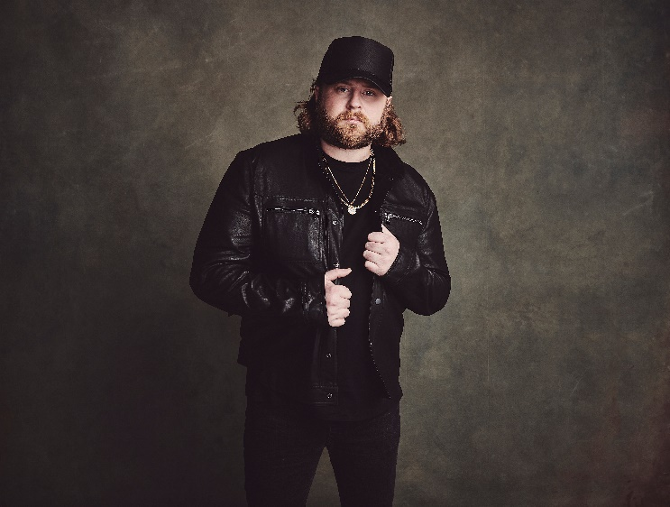
Featuring a mix of gritty backwoods soul, rock ‘n’ roll swagger and velvet-thunder vocals, Nate Smith is Sony Music Nashville’s latest signing whose personal journey inspired him to be a beacon of country-music hope, an inspirational mission he puts front-and-center. A Paradise, California native, former worship leader, and lifelong music lover, Smith approaches that mission with a background as eclectic as it gets. Learning guitar at 13, Garth Brooks, Elvis Presley and Bob Seger were among those informing his powerful, fire-from-within vocals, while Michael Jackson made him crave the spotlight and Nirvana gave his sound a jagged edge.

- Country powerhouse Nate Smith’s single “World On Fire” is now a multi-week No. 1 hit. It reached No. 1 on country radio in December 2023 and remained at the top of the Billboard Country Airplay charts for nine weeks (as of 2.13.24).
  - The accomplishment ties Morgan Wallen’s “Last Night,” Alan Jackson and Jimmy Buffett’s “It’s Five O’Clock Somewhere” and Lonestar’s “Amazed” for the second-longest No. 1 chart reign since Country Airplay began in 1990.
  - “World On Fire” also hit No. 1 on the Mediabase/Country Aircheck chart for three weeks.
  - The song has over 180 million total global streams.
  - He recently performed the hit on NBC’s TODAY. Watch here.

- Smith released his latest anthemic single, “Bulletproof,” in February. Watch the music video here.

- He recently announced his Through The Smoke EP, arriving April 5. Smith said about the project, “I’ve been through a lot of adversity in my life, but ‘through the smoke’ came to mind one day and I thought that was the perfect way to describe making it through tragedy. It captures what it looks like on the other side of heartbreak, on the other side of tragedy, on the other side of giving everything you’ve got to go after what you want to do in life. I think this EP is a transition between all the fire and pain and everything I went through, and then overcoming. And that’s what I want people to feel. It’s layered in there.”

- Smith’s debut, self-titled album is out now along with the deluxe version, released the same day (4/28).
  - Earned the largest album debut from a new artist this year + largest full length album debut from a new artist since 2020 at the time of release.
  - Hit #6 on Billboard’s Country album charts and #30 on the Billboard Top 200.

- As a 49ers fan, Nate performed during the NFC Championship pregame show on January 28th before the Lions and 49ers game kicked off.

- Touring:
  - Nate recently kicked off his headline WORLD ON FIRE TOUR 2024. The tour will hit 21 cities including Chicago, Indianapolis, LA, Las Vegas, NYC and Sacramento.
  - Will hit the road with Morgan Wallen for his ONE NIGHT AT A TIME 2024 tour this spring/summer.
  - Toured with Cole Swindell fall of 2023.
  - Nate was part of Thomas Rhett’s HOME TEAM TOUR 23 last summer, hitting 40 cities.
  - Nate will return to Stagecoach in 2024, after making his debut at the festival in 2023.

- His debut, Platinum-certified single “Whiskey On You” hit No. 1 for two weeks in a row earlier this year.
  - The song amassed over 7.5 million total global on-demand streams in its first week, reaching No. 10 on the Country On-Demand Streaming Chart.
  - The track debuted at No. 84 on the Billboard Hot 100 and No. 14 on the Hot Country Songs chart, marking Smith’s first career entry on the chart.
  - He also re-entered Billboard's Emerging Artists chart at No. 1, becoming the top emerging act in the U.S. for the first time.
  - The song has amassed nearly 420 million total global on-demand streams to date.
  - Nate performed the song on “The Tonight Show Starring Jimmy Fallon” earlier this year.
  - Performed “Whiskey On You” at the 2023 CMT Music Awards where he was also nominated for Male Breakthrough Video Of The Year for the song.

- Nate has amassed over a billion career streams globally to date.

- Has achieved four No.1s on SiriusXM The Highway’s Hot 30 Weekend Countdown: “Whiskey On You,” “I Found You,” “Better Boy,” and “World On Fire.”

- Smith performed on the Platform Stage at Nissan Stadium during this year’s CMA Fest.

- Nominations:
  - Nominated at the 2024 iHeartRadio Music Awards for BEST NEW ARTIST (COUNTRY).
  - Nominated for ACM New Male Artist of the Year at the 58th ACM Awards (2023).
  - 2023 CMT Awards nomination for BREAKTHROUGH MALE VIDEO OF THE YEAR for “Whiskey On You.”

- Nate was named an Amazon Breakthrough Artist to Watch for 2023, one of MusicRow’s Next Big Things, part of CMT’s Listen Up class for 2023, CRS New Faces, plus more.

- The “Nashville powerhouse” (E! News) was the final member of the Grand Ole Opry’s NextStage Class of 2022.

- Has over 2 million followers across his social channels

- Nate lost everything he owned in the devastating Camp Fire which tore through his hometown of Paradise, California in 2018, now known as the deadliest and most destructive wildfire in the state’s history. Although his family was safe, he struggled to cope and turned to music for comfort, using a loaned guitar to co-write a song called “One of These Days.” The overwhelming response to the song inspired him to make the voyage to Nashville to pursue his dream of becoming a country music star, prompting a month-long road trip across the U.S. writing music and playing dive bars along the way.

NateSmithOfficial.com | Instagram | Facebook | TikTok | YouTube

