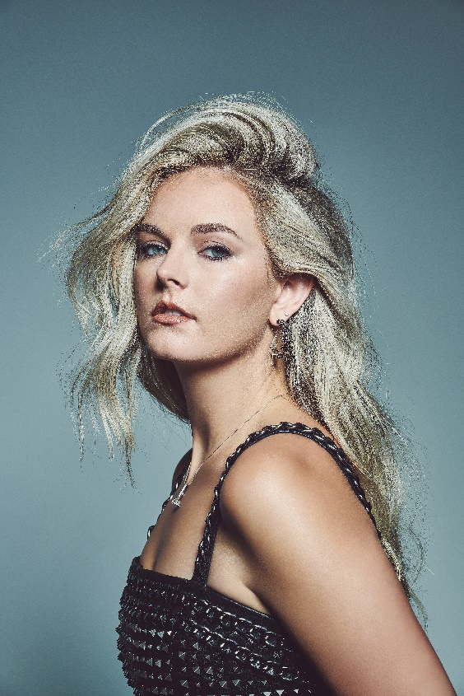
•Exciting country newcomer Karley Scott Collins' musical journey began when she took up guitar as a young girl and began writing her own songs. Her diverse musical tastes, ranging from rock bands like Guns N’ Roses to country legends like Willie Nelson and iconic songwriters like Bob Dylan, have significantly shaped her unique musical style.

•Her Sony Music Nashville debut EP, Hands on the Wheel, showcases her talent for authentic storytelling with soulful grit. The EP explores a spectrum of emotions from love to heartbreak, with each track delving into different facets of romantic relationships and reflecting her deep emotional connection to her music.

•Her latest release “Heavy Metal,” which she co-produced with Grammy Award winner Nathan Chapman, addresses the complexities of a broken marriage, drawing from personal experiences close to her and highlighting the impact of unfulfilled promises in a relationship. It is her fastest-growing track release to date.

•Served as direct support on Larry Fleet's nationwide fall tour, performing in cities including Huntington, N.Y., Montclair, N.J., Norfolk, Va., and Huntsville, Ala.

•Prior to touring with Fleet, Karley had toured with Nate Smith, made her debut at CMA Fest, performed multiple times at Nashville mainstay Whiskey Jam, and shared the stage with Little Big Town, Caitlyn Smith, and more.
•Karley is actively writing and recording, with new music to be released soon. She is also included on C2C’s Introducing Nashville lineup that will consist of 7 shows across Europe.
KarleyScottCollins.com | Instagram | Facebook | TikTok | YouTube
Media Contact:
Courtney Beebe
Sony Music Nashville
Courtney.beebe@sonymusic.com

