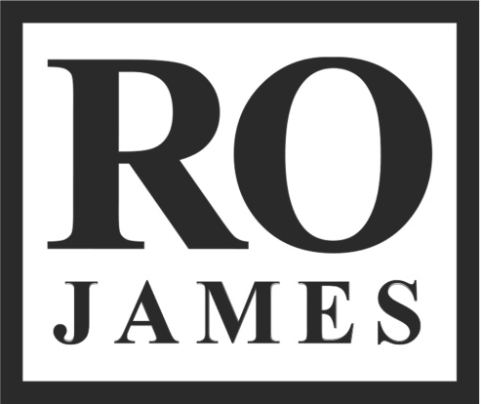

Ro James was a self-made rebel by grade school. Born in Stuttgart, Germany, the singer (real name Ronnie James Tucker) would jam out to the diverse sounds of Johnny Cash, Biggie, Tupac, Sly and the Family Stone and David Bowie while his father -- a military man turned preacher -- tried to push church music into his ears.

“We were kept from doing a lot of things like going to the movies and that's what would make me rebel, because I was like, I don't understand this,” he recalls. “All my friends are going to the movies and listening to all these different songs that I don't even know because you're only allowing me to listen to gospel songs.” Papa Tucker would also encourage his son to sing, but he wouldn’t utter a note in public after being intimidated by hearing his family’s talents in church. “They were so good at what they did,” he says. “I didn't feel like I was that good.”

His defiant spirit soon changed that. James spent his childhood in different corners of the country including Indiana, California, Hawaii, Oklahoma and eventually his current place of residence, New York. He admits that the change in scenery influenced him to try and fit in. “As a kid, you go [to these different places] and everybody's not wearing Jordans, they're wearing cowboy boots. And it's like, I want some cowboy boots too!” he says.

Through his aunt, a former singer for Prince, James learned to embrace the idea of different by discovering his musical muse in Purple Rain. “His ability to be himself and not really care what anyone else thought, I just related,” he says. “You feel like you're a part of the crowd and you have to fit [in], but you really don't fit.” James landed in a studio for the first time at 19 years old, but honed his songwriting prowess through the reading and writing punishments his mother would hand him for bad behavior. Once, he got suspended in the seventh grade for five days after stealing a teacher’s wallet to order pizza for the class. “She used to make me read all those fiction novels like Goosebumps,” he says, noting that she once made him copy a book. “I got into Shakespeare and all of that stuff in high school and then got out of it because it got too complicated, but all of those things just helped me to put words together. It gave me a different perspective.”

Soon, the blatant badass was scribing from the perspective of a smooth operator. Whether reflecting on heartbreak in the first song he ever wrote called “Portrait” or finding a deeper connection than sex on one of his EP cuts “A.D.I.D.A.S.,” he would spin matters of the heart into poignant slow jams that went down smoother than his whiskey of choice, Jack Daniel’s.

In 2013, James took the independent route, performing at showcases throughout New York and collaborating with the city’s up-and-comers like Luke James and Wynter Gordon. He eventually rolled out a three-part EP called Coke, Jack and Cadillacs, all odes to his firsts. “Coke was about my first girlfriend, Jack was myself and Cadillac was my first car,” he says. In the span of the three projects, James’ slick tongue, badass vibe and soulful melodies would become his signature and even earned him comparisons to his musical idol D’Angelo.

Now, he’s committed to remaining himself note-by-note, especially after signing to Mark Pitts’ ByStorm Entertainment/RCA Records, the home of his debut major label single “Permission.” His upcoming album will take the name ELDORADO, inspired by the place he calls his city of gold. “I wanted to liken that to my journey from Indiana to New York -- New York being my city of gold -- and just pursuing my dream,” he says. “That's where I started.”

