SIA WOWS AT COACHELLA 1ST WEEKEND
PRODUCTION DETAILS REVEALED
UPCOMING PERFORMANCE 2ND WEEKEND AT COACHELLA, THIS SUNDAY 4/24
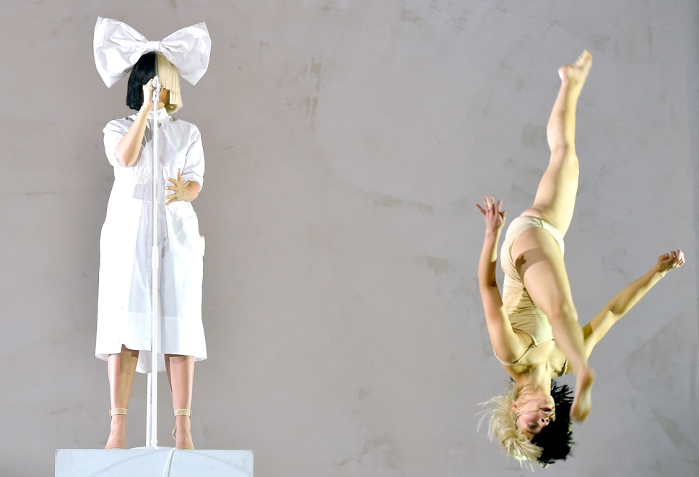

“Coachella is losing its shit over Sia’s performance” - Consequence of Sound

“… the ever-iconic Sia performed at Coachella over the weekend, and her set was freakin’ legendary…will blow your goddamn mind”- Buzzfeed

“a stunning star-laden set” - Billboard

“The stuff of legend” - NYLON

“She brought down the house. The set is being heralded as one of the festival’s best.” TIME
“otherworldly vocals …The day – and really, the entire festival – belonged to pop provocateur Sia, whose ambitious hour-long concert was one of the greatest moments in Coachella’s 17-year history.” - Yahoo Music
“Talk about a night you won't forget!”- Teen Vogue

“Sia delivered an hour-long set at the annual music festival that has since left ticket-holders in a state of awe” – Popcrush

(New York - April 19, 2016) Sia, known for her killer vocals, compelling videos and emotional choreography brought it all in a big way to her Coachella set this past weekend, which was her first full live concert in 5 years, receiving sweeping critical raves. Sia will be performing again this weekend at Coachella on Sunday evening.

The bulk of Sia’s set list is featured on her current album THIS IS ACTING:

Set list includes Alive, Diamonds, Cheap Thrills, Big Girls Cry, Bird Set Free, Reaper, One Million Bullets, Elastic Heart, Unstoppable, Breathe Me, Move Your Body, Titanium, Chandelier.

Find below a list of personnel who contributed to Sia’s Coachella performance:

Directed by: Sia, Daniel Askill.
Choreography by: Ryan Heffington.
Creative Direction by: Sia, Daniel Askill, Ryan Heffington.
On stage dancers: Nick Lanzisera, John Litzler, Stephanie Mincone, & Wyatt Rocker.
Cast: Paul Dano,Gaby Hoffman, Ben Mendelsohn, Tig Notaro, Maddie Ziegler, and Kristin Wiig.

In advance of Coachella, Sia released 2 EPs, SIA SPOTIFY SESSIONS, featuring six songs in total, four from her critically-acclaimed current chart-topping album THIS IS ACTING plus “Chandelier” and “Elastic Heart.” CLICK HERE to listen now on Spotify and CHEAP THRILLS REMIX EP, available now at all digital providers. CHEAP THRILLS REMIX EP bundles 7 remixes of her current single by Hex Cougar, Le Youth, RAC, Nomero, Sted-E & Hybrid Heights, Cyril Hahn, and John J-C Carr.

http://siamusic.net/
https://instagram.com/siathisisacting/
https://twitter.com/Sia
https://www.facebook.com/SiaMusic
http://www.youtube.com/user/SiaVEVO

Sia Photo credit: Kevin Winter/gettyimages

Media contact:

Sarah Weinstein Dennison/ RCA Publicity
212-833-5593 Sarah.weinstein@rcarecords.com

