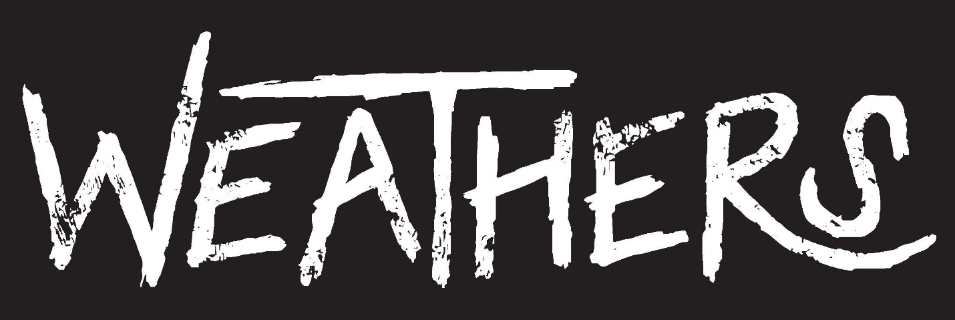
With an average age of 19, the members of Weathers — lead singer/rhythm guitarist Cameron Boyer, guitarist Cameron Olsen, bassist Brennen Bates, and drummer Cole Carson — are part of the post-Millennial Generation Z: Social media-saturated kids who grew up in an insecure post-9/11 world and raised by financially stressed parents affected by the economic downturn. It’s no wonder that a skeptical, unsettled mood permeates the songs that the Los Angeles-based band has written since they officially became Weathers in October 2015.

“I've got a lot of friends who have had a hard time coping with being out of high school,” Boyer says. “They fell into this pit of feeling like, ‘I’m lost. I’m trying to find a job, but I can’t. Then they get hooked on some sort of drug and are convinced they’re happy, but they're not. I think our songs speak to those people at this in-between stage of trying to find themselves, and asking ‘Is the American Dream a real thing, or is it just propaganda?’ We're basically holding hands with all of those people having a tough time and telling them, ‘We’ll help you through it with our music.’”

Weathers’ darkly tinged, guitar-driven alt-rock songs like “Happy Pills” and “American Dream” paint a vivid picture of young people who “can’t function without weed” struggling not only to find jobs, but also an identity. “Happy Pills” is an ironic indictment of dependency, as is “Sucker,” which posits that lust for another person can be just as destructive as a lust for money or drugs if you’re not confident in yourself. And “Brass Knuckles” is a warning not to go through life unprepared so you don’t become reliant on anything or anyone. “It’s a wake-up call to toughen up,” Boyer says. But despite the social commentary, Weathers’ songs are ultimately filtered through the band’s deeply personal lens. They are singing about themselves, their peers, and the characters they’ve met along their journey to becoming a band. In the songs, Weathers long for authenticity; for people to look up from their phones and make a real connection.

Weathers’ first shot across the bow — “I Don’t Wanna Know” — finds the band shutting out the white noise and adopting an “us against the world” gang mentality. Says Boyer: “When we wrote it, I remember thinking, ‘I'm at a stage where I'm taking the band seriously. I don't want to know anything about what you're doing. I don't want to know what your friends are doing. I don't even want to know what my friends are doing. I just want to focus on the band. I love music, I love these guys, and I really want to make this work.’”

It was after writing “I Don’t Wanna Know” that the band knew they were onto something special with their sound and their message. “It was the first song we wrote where we thought, ‘This is something that we would listen to,’” Cameron Olsen says. “We were all in the room together and we were like, ‘This is it.’”

The two wanted to aim higher. Boyer’s earliest musical memories are of listening to The Beach Boys’ Greatest Hits with his dad, while Olsen was raised on a steady diet of Journey, Cheap Trick, Bryan Adams, and Guns ’N Roses. Both began singing, writing songs, and teaching themselves to play guitar (and piano, in Boyer’s case) as kids, and fronting bands. They met four years ago at a local Battle of the Bands in Manhattan Beach. Brennen Bates was already in Boyer’s band at this point, having met him through a Facebook message Boyer posted looking for a bassist. With Olsen on board, the fledging group needed a drummer. Boyer’s father and Cole Carson’s father played in a band together in their tiny Illinois hometown years ago, but their sons had never met until Boyer’s dad suggested Cameron meet his friend’s son. “We watched Cole play drums on YouTube,” Boyer recalls. “I’m not exaggerating when I say that Cole is one of the best drummers I’ve ever seen. I was blown away.”

With the line-up complete, the guys set to writing songs and honing their live show — an electrifying spectacle where the self-described introvert Boyer finally comes out of his shell. “Everything I wish I could scream in person becomes possible onstage,” he says. “I just let it all out. I bottle everything up offstage, so when we perform, I go nuts.” Weathers has played Webster Hall in New York City and The Troubadour in Los Angeles, and performed at this year’s SXSW. In April, they signed with RCA Records and are hard at work on their debut album. “When people listen to our music, we want them to feel like they’ve been heard,” Boyer says. “We want them to reflect on themselves and to have a good time doing it.”

###

