A PENTATONIX CHRISTMAS DEBUTS AT #3 ON THE BILLBOARD TOP 200 CHART AND #1 ON THE HOLIDAY ALBUMS CHART
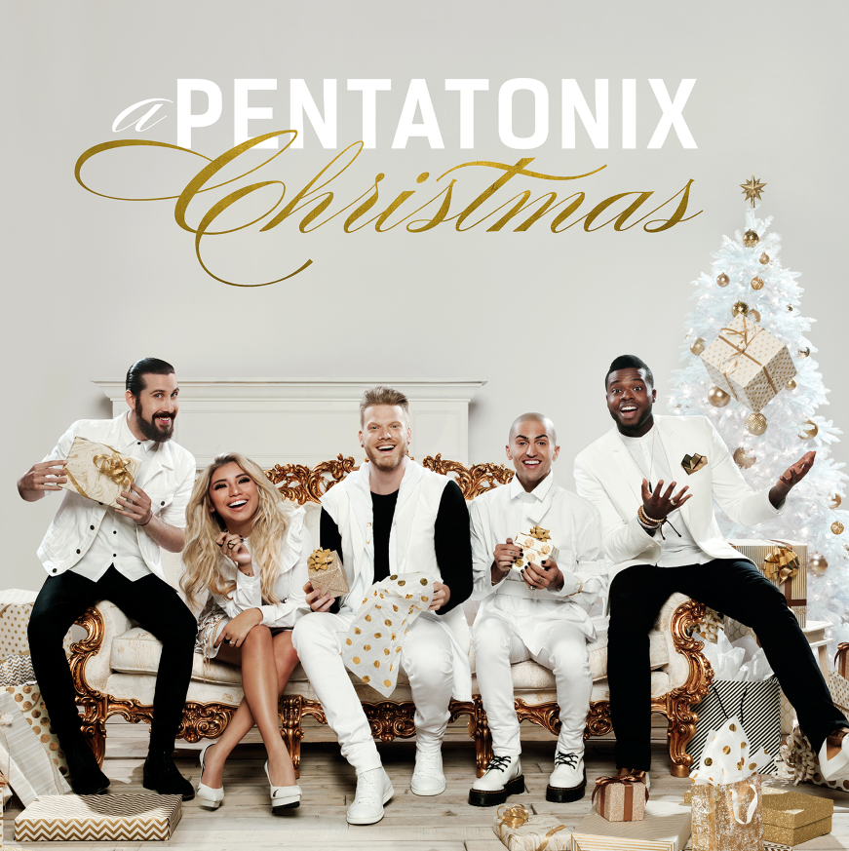
“Hallelujah” Music Video Generates More Than 20 Million Views In Its First Week Of Release; Track Reaches #6 on Billboard’s Top Digital Songs Chart
Watch The Video Here
Confirmed To Perform At The 50th Annual CMA Awards
Featured In NBC’s Thursday Night Football Opening Theme Song
(New York, New York) – A Pentatonix Christmas - the newest release from Grammy Award winning and multi-platinum recording artist Pentatonix - debuted at #3 on the Billboard Top 200 Album Chart and #1 on the Holiday Albums Chart, selling over 60,000 total equivalent units. This marks the 20th week the group has been #1 on the seasonal chart during the holiday season. A Pentatonix Christmas reached #1 on iTunes Top Albums Chart and remains #1 on Amazon’s physical CD best sellers chart.
The group released the music video for their arrangement of the Leonard Cohen classic “Hallelujah” (watch here), which generated more than 20 million views in its first week and currently has over 26.4 million views. The track debuted at #6 on Billboard’s Digital Songs Chart, reached #2 on the iTunes Top Songs Chart and is in the top 15 on Spotify’s U.S. and Global Viral Charts. USA Today said that their performance “will leave you speechless,” while TIME coined it “a fresh, thrilling new spin.” The Today Show said, “they deliver chilling vocal performances of the song,” while Billboard called it “a powerful cover.”
The group will perform at The 50th Annual CMA Awards this Wednesday, November 2nd. The following night, they will be featured in NBC’s Thursday Night Football opening, where they will debut and perform “Weekend Go,” which reimagines the group’s original track “Sing” for NBC and The NFL Network’s upcoming TNF broadcasts. Earlier this fall, the group released a duet with Dolly Parton of “Jolene.” Their video has been viewed over 14.5 million times (watch here).
The group is currently touring North America on the final leg of their 2016 Pentatonix World Tour in support of their self-titled album. The album debuted at #1 on Billboard’s Top 200 chart and has been certified gold. For more information on the tour and tickets, please visit ptxofficial.com/tour.
A Pentatonix Christmas follows 2014’s highly successful 2X platinum holiday album That’s Christmas To Me, which features the group’s Grammy Award winning arrangement for “Dance of the Sugar Plum Fairy.” Cumulatively, their holiday albums have sold over 2.5 million copies in the U.S. and their holiday videos have over 370 million views on YouTube.
In just five years, Pentatonix has sold more than 3.5 million albums in the U.S. alone. They have won 2 Grammy Awards and performed for hundreds of thousands of fans at their sold-out shows across the globe. Their YouTube channel boasts more than 11 million subscribers, yielding nearly 2 billion video views. All 7 Pentatonix album releases have debuted in the chart’s Top 10. In 2015, the group released its first tour documentary On My Way Home and appeared in the feature film Pitch Perfect 2.

For More Information:
Official Website: http://ptxofficial.com/
YouTube Page: http://youtube.com/Ptxofficial
Facebook: https://www.facebook.com/Pentatonix
Press Assets: http://www.rcarecordspress.com/artist/pentatonix
Get it on Amazon Music: http://smarturl.it/APTXMASAMZ
Listen on Apple Music: http://smarturl.it/APTXMAS
Buy on iTunes: http://smarturl.it/APentatonixChristmas
Stream on Spotify: http://smarturl.it/StreamAPTXMAS

Contact:
Meghan Kehoe – RCA Records – Meghan.Kehoe@rcarecords.com

